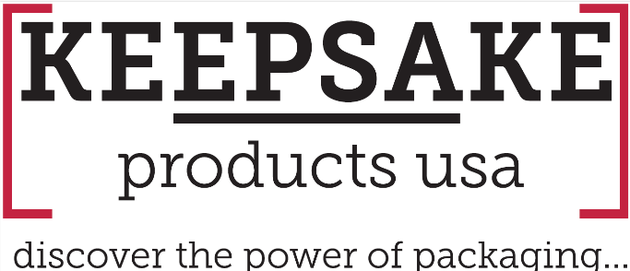
Why Packaging Is Harder Than a Mug—And Why That’s a Good Thing

In the promotional products world, it’s easy to default to what’s simple. A mug is straightforward. You pick a style, add a logo, and move on.
Packaging isn’t like that. And that’s exactly why it’s so powerful.

Complexity Creates Opportunity
Packaging requires more thought. More customization. More creativity.
You’re not just choosing an item—you’re building an experience. Structure, materials, branding, inserts, and presentation all come into play. There are more decisions to make, and at first glance, that can feel like friction.
But that complexity is where the opportunity lives. Because the harder something is to execute, the fewer people are doing it well. And when you do it well, you stand out.

Packaging Changes the Conversation
Clients don’t get excited about another mug. They respond to packaging because it elevates everything inside it.
- It transforms a product into a moment.
- It enhances brand perception.
- It creates a cohesive, memorable experience.

Instead of selling a single item, you’re delivering something that feels intentional, curated, and premium. That shift changes how clients perceive value—and what they’re willing to invest.

From Transactional to Strategic
When you introduce packaging into the conversation, you move beyond transactional selling. You’re no longer competing on price alone. You’re guiding clients through how their brand shows up, how it’s experienced, and how it’s remembered. That’s a much more defensible—and profitable—position.

You Don’t Have to Do It Alone
One of the biggest misconceptions about packaging is that it’s difficult to manage. “The truth is, it’s only hard if you try to do it alone.” Explains Andy Griffin, Managing Partner at Keepsake Products USA
With the right partner, the complexity becomes manageable. You get support across design, sourcing, kitting, and execution—so you can focus on leading the strategy, not chasing the details.
That’s where Keepsake comes in. Keepsake simplifies packaging by supporting distributors at every step of the process. From concept to delivery, you have a team helping you bring ideas to life without the usual friction.

The Advantage Is in the Effort
Yes, packaging is harder than a mug. But that extra effort is what creates differentiation. It’s what drives stronger client engagement, better brand experiences, and ultimately, more profitable programs.
In a crowded market, easy doesn’t win. Thoughtful does. And packaging is one of the most powerful ways to prove it.

For more ideas, visit: https://keepsakeproductsusa.com/
Interested in more information contact:
Keepsake Products USA
(973) 816-2324
info@keepsakeboxusa.com

